SIMATS ENGINEERING
ASSESSMENT TOOL 2: Scenario-Based

COURSE NAME: Cloud Computing and COURSE CODE: CSA1515
Big Data Analytics

COURSE OUTCOME COVERED
CO2: Analyze virtualization architectures to identify performance and security issues in cloud computing environments. (BL3)
Assessment Tool Weightage: 20%

Dave's Taxonomy: Manipulation (Level 2) Total Marks: 25
Question Count: 5

Code of Conduct
IARTHI REDDY(192565054) (Name / Reg No) certify that this submission is my original work and that I have adhered to the guidelines specified for this assessment.
I understand that any violation of academic integrity rules will result in disciplinary action.
Signature of the student: arthireddy

Assessment Tasks
Application Based Questions
1. How would virtualization help a company reduce hardware cost and improve utilization in a new cloud
datacenter?
2. A startup needs rapid server provisioning for testing and deployment. Explain how hypervisors and virtual
machines support this requirement.
3. How can SOA help integrate cloud services developed by different teams? Explain with an application-oriented
example.
4. Explain how identity management and privacy controls should be applied in a federated cloud used by partner
organizations.
5. A business wants to migrate from isolated physical servers to a software-defined datacenter. Explain the
practical benefits they can expect.

Application Based Questions Rubric
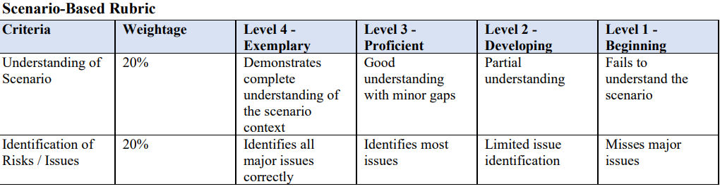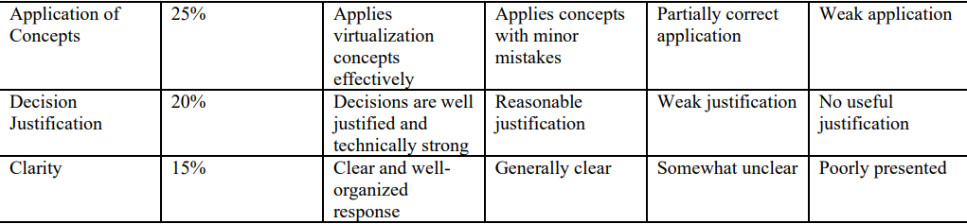

1. Virtualization and Hardware Cost
Virtualization allows one physical server to run multiple Virtual Machines (VMs) using a hypervisor.
- Multiple VMs share the same physical CPU, memory, storage, and network resources.
- Fewer physical servers are required, reducing hardware purchase and maintenance costs.
- Server utilization increases because unused resources can be shared by other VMs.
- It also reduces power, cooling, and datacenter space requirements.
- VMs can be created, moved, or resized easily.
Example: Instead of using 10 physical servers for 10 applications, a company may use 3–4 powerful physical servers and run 10 VMs on them.

2. Hypervisors and Virtual Machines for Rapid Provisioning
A hypervisor is software that creates and manages Virtual Machines.
- A VM can be created from a preconfigured template in minutes.
- Developers can create separate VMs for testing, development, and deployment.
- Multiple VMs can run different operating systems on the same physical server.
- VMs can be cloned quickly for additional testing environments.
- After testing, unwanted VMs can be deleted without affecting the physical server.
Example: A startup can create a Linux VM for testing an application, clone it for another developer, and deploy the tested VM quickly.
Result: Faster provisioning, lower cost, and improved development speed.

3. SOA for Integrating Cloud Services
Service-Oriented Architecture (SOA) divides an application into independent services that communicate through standard interfaces.
Different teams can develop and maintain different cloud services while allowing them to work together.
Application Example: Online Shopping System
- Team 1: Develops the Customer/Account Service.
- Team 2: Develops the Payment Service.
- Team 3: Develops the Inventory Service.
- Team 4: Develops the Delivery Service.
The services communicate through APIs or standard web services.
For example:
Customer → Order Service → Payment Service → Inventory Service → Delivery Service
Each team can update its own service without completely changing the other services.
Benefits: Reusability, flexibility, easier integration, independent development, and easier maintenance.

4. Identity Management and Privacy in a Federated Cloud
A federated cloud allows different partner organizations to share cloud resources.
Identity management should ensure that only authorized users can access resources.
- Use Single Sign-On (SSO) so users can access authorized services with their organization identity.
- Use Multi-Factor Authentication (MFA) for stronger security.
- Apply Role-Based Access Control (RBAC) to give users only the permissions they need.
- Use identity federation standards such as SAML or OAuth/OpenID Connect.
- Encrypt sensitive data during storage and transmission.
- Apply privacy policies to control how partner organizations access and share data.
- Maintain audit logs to track user activities.
Example: In a healthcare federated cloud, Hospital A users should access only the patient data and services permitted to them, while Hospital B users receive their own authorized access.
Result: Secure resource sharing while protecting user identity and sensitive data.

5. Benefits of a Software-Defined Datacenter
A Software-Defined Datacenter (SDDC) manages computing, storage, and networking using software instead of relying mainly on dedicated physical hardware.
Practical benefits include:
- Lower hardware costs: Resources can be consolidated and shared.
- Better utilization: CPU, memory, storage, and network resources are dynamically allocated.
- Automation: Servers and applications can be provisioned automatically.
- Scalability: Resources can be increased or decreased quickly according to demand.
- Centralized management: Infrastructure can be controlled through software-based management tools.
- Faster deployment: New applications and services can be deployed quickly.
- Improved flexibility: Resources can be reconfigured without major hardware changes.
- Disaster recovery: VMs and workloads can be moved or restored more easily.
Example: A company can automatically allocate additional virtual servers during high customer demand and release them when demand decreases.
Overall result: An SDDC provides lower cost, higher utilization, faster deployment, better scalability, and easier management.

